# Section1: Test models

In this section we will discuss the alternative fuzzy inference systems that were created alongside the final model. There will be three models each having their own characteristics, which we will discuss in further detail.

First we make some basic assumptions about the human body whilst keeping as abstract as possible as this is not a real medical system. We take the assumption that age, gender and other factors are ignored as the variance would be too great. Next we assume the heart rate is measured when the heart is at rest, as mentioned before several factors can affect the heart rate if we take the heart rate after exercise. Lastly we assume the lower and upper bounds of both the temperature and heart rate to be a set range and anything below or higher than this range is considered requiring the highest priority, this again is to simplify the models and ignore variances from different factors such as medical conditions.

It was decided there would be three alternative models that each will contains 2 input variables and 1 output variable named, temperature, heart rate and urgency respectively. Each input variables has 5 member functions and the output variable has 3 member functions, and that the results gathered are all results without tuning, so to prove which of the three member functions is generally more accurate alongside this, a set of rule (fig 2) is created which will be used for all three models, this is to reduce implementation time and also to ensure the results can be directly compared to each of the other models results. (see appendix apx1-2 for target set and it’s visual representation)

Fig:1 Heart1 FIS structure Fig 2 Ruleset

"[Input1]"

"Name='Temperature'"

"Range=[14:46]"

"MF1='very cold':'trapmf',[14 14 23.5 33 1]"

"MF2='cold':'trapmf',[32 33 34 35 1]"

"MF3='normal':'trapmf',[34 36 36.25 38 1]"

"MF4='hot':'trapmf',[37 38 39 41 1]"

"MF5='very hot':'trapmf',[40 42 46 46 1]"

"[Input2]"

"Name='Heart Rate'"

"Range=[0:100]"

"MF1='Very Slow':'trimf',[0 19.5 39 1]" "MF2='Above Normal':'trimf',[40 52.5 65 1]"

"MF3='Normal':'trimf',[62 70 78 1]"

"MF4='Below Normal':'trimf',[70 77 84 1]"

"MF5='Very Fast':'trimf',[82 91 100 1]"

"[Output1]"

"Name='Urgency'"

"Range=[0:100]"

"MF1='No Need':'trimf',[0 20 40 1]"

"MF2='Concerning':'trimf',[35 52.5 75 1]"

"MF3='Urgent':'trimf',[70 85 100 1]"

1. If (Temperature is very cold) then (Urgency is Urgent) (1)

2. If (Temperature is cold) then (Urgency is Urgent) (1)

3. If (Temperature is normal) and (Heart Rate is Very Slow) then (Urgency is Urgent) (1)

4. If (Temperature is normal) and (Heart Rate is Above Normal) then (Urgency is No Need) (1)

5. If (Temperature is normal) and (Heart Rate is Normal) then (Urgency is No Need) (1)

6. If (Temperature is normal) and (Heart Rate is Below Normal) then (Urgency is No Need) (1)

7. If (Temperature is normal) and (Heart Rate is Very Fast) then (Urgency is Urgent) (1)

8. If (Temperature is hot) and (Heart Rate is Very Slow) then (Urgency is Urgent) (1)

9. If (Temperature is hot) and (Heart Rate is Above Normal) then (Urgency is Concerning) (1)

10. If (Temperature is hot) and (Heart Rate is Normal) then (Urgency is Concerning) (1)

11. If (Temperature is hot) and (Heart Rate is Below Normal) then (Urgency is Concerning) (1)

12. If (Temperature is hot) and (Heart Rate is Very Fast) then (Urgency is Urgent) (1)

13. If (Temperature is very hot) then (Urgency is Urgent) (1)

#### Model 1 - triMF

In the first model (fig 1), it was decided to use triMF for all the member functions,

As part of three models to achieve the ideal Fuzzy inference structure (see appendix). Other modifications include using trapMF and gaussMF (more detail below) , these were created to compete which each other to find which member function type is best suited for the final version which I talk about in a later section

From the graphical representation (fig 3) and the root square mean error average of [35.06371(see also appendix apx 3] it can be determined that the use of triMf is possible but not that useful in terms of reliable data, this is because of how each member function is formed to produce a crisp result at its means and low results at its edges, as a result, some scenarios where medical emergency is needed appears to have a urgency value comparable to a completely healthy person.

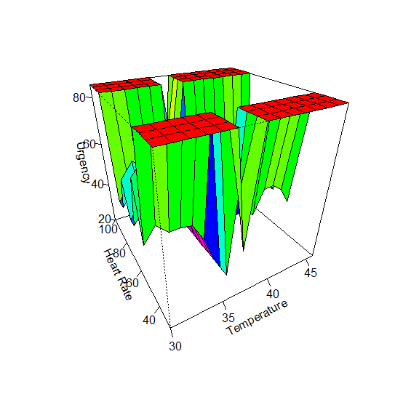

Fig 3 – gensurf graph of model 1

#### Model 2 - trapMF

From this first model several modification have been made to accommodate for a more reliable and accurate results, an observation worth noticing from the first example is that a range of values fall under one category instead of a single point, thus to achieve this kind of result it as decided on the second model (Fig 4), to use trapMF as it gives a flat line at its peak for results that needed to be consistent and require less variance between data points i.e. as temperature increase from 30c to 36c, this should be displayed as flat lining at the peak (30c)and gradually getting lower in terms of urgency till it reaches the end of its segment (36c) .

Fig 4 Model 2 FIS structure

|  |  |
| --- | --- |
| "[Input1]"  "Name='Temperature'"  "Range=[30:46]"  "MF1='v,cold':'trapmf',[29 29 31 33 1]"  "MF2='cold':'trapmf',[32 33 34 35 1]"  "MF3='m.cold':'trapmf',[34 34.5 35.5 36 1]"  "MF4='normal':'trapmf',[35 35.5 36.5 37 1]"  "MF5='m.hot':'trapmf',[36 36.5 37.5 38 1]"  "MF6='hot':'trapmf',[37 37.5 40.5 41 1]"  "MF7='v.hot':'trapmf',[40 40.5 47 47 1]" | "[Input2]"  "Name='Heart Rate'"  "Range=[30:100]"  "MF1='v.Slow':'trapmf',[29 29 37 39 1]"  "MF2='Slow':'trapmf',[38 40 44 46 1]"  "MF3='Slowish':'trapmf',[45 47 53 55 1]"  "MF4='Normal':'trapmf',[54 56 68 70 1]"  "MF5='Fastish':'trapmf',[69 71 76 78 1]"  "MF6='Fast':'trapmf',[77 79 82 84 1]"  "MF7='v.Fast':'trapmf',[83 85 101 101 1]" |
| "[Output1]"  "Name='Urgency'"  "Range=[0:100]"  "NumMFs=3"  "MF1='fine':'trapmf',[0 0 35 40 1]"  "MF2='Concerning':'trapmf',[40 45 65 70 1]"  "MF3='Urgent':'trapmf',[70 80 95 100 1]" | |

Looking at model 2’s gensurf graph (fig 5) in comparison to the target set graph (see appendix apx 2), and more importantly, in comparison to model 1’s gensurf graph (fig 3), in terms of shape and overall appearance both model1 and model 2 appear to be similar and are vaguely similar to the target set , what this means is the FIS structure would require some modifications to produce a “smoother” graph, by which the graph looks to have a more gradual descent instead of a sudden drop as seen in model 1 and model 2.

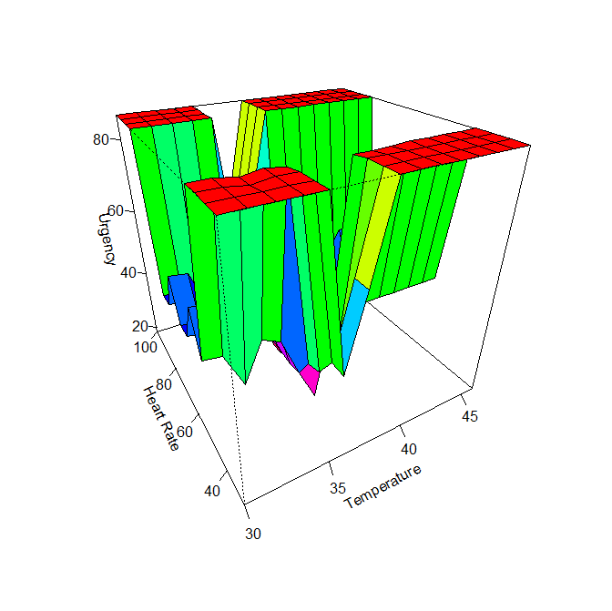

Fig 5 – gensurf graph of model 2

In term of results (see appendix apx 3) , it can be determined quite easily that trapMF is significantly better as it produces a RMSE average of [8.836405141] which is approximately, a 400% more accurate result in comparison to model 1, which could conclude my theory that the use of flat lining at peak areas is a characteristic that has proven from the RMSE Average to be able to produce more accurate results

#### Model 3

In the final model (fig 6), I will be using gaussMF, the decision for this member function type is because looking at the variable in a biological perspective, we can see that he human body is never constant or entirely predictable, and as a result at times of emergency the growth rate cannot be a constant elevation as that with trapMf but rather exponential which produces ranges that can start from a flat line/ slow growth to near sudden growth in a very short amount of time, therefore it produces a more realistic approach to how urgent a patient should be treated that should give the FIs a more accurate reading.

Fig 6 – model 3 FIS structure

|  |  |
| --- | --- |
| "[Input1]" "Name='Temperature'"  "Range=[30:46]"  "MF1='v,cold':'gaussmf',[0.89 30 1]"  "MF2='cold':'gaussmf',[0.75 33.75 1]"  "MF3='m.cold':'gaussmf',[0.17 34.75 1]"  "MF4='normal':'gaussmf',[0.6 36.5 1]"  "MF5='m.hot':'gaussmf',[0.32 37.5 1]"  "MF6='hot':'gaussmf',[1.04 39.25 1]"  "MF7='v.hot':'gaussmf',[1.62 46 1]" | "[Input2]"  "Name='Heart Rate'"  "Range=[30:100]"  "MF1='v.Slow':'gaussmf',[3.16 30 1]"  "MF2='Slow':'gaussmf',[2 42 1]"  "MF3='Slowish':'gaussmf',[3.16 50 1]"  "MF4='Normal':'gaussmf',[4.61 62.5 1]"  "MF5='Fastish':'gaussmf',[2.87 73.5 1]"  "MF6='Fast':'gaussmf',[2 81 1]"  "MF7='v.Fast':'gaussmf',[4.61 100 1]" |
| "[Output1]"  "Name='Urgency'"  "Range=[0:100]"  "MF1='fine':'gaussmf',[11.83 0 1]"  "MF2='Concerning':'gaussmf',[9.233 54.5 1]"  "MF3='Urgent':'gaussmf',[9.233 100 1]" | |

in model 3’s graph (fig 6), again it looks more similar to the target set (see appendix apx 2) in comparison to the other models (fig 3,fig 5), however as mentioned before there are still steep decline and inclines which indicate perhaps the output variable should be modified to accommodate a more broad range of outputs, thus giving a more smoother transition between urgency levels.

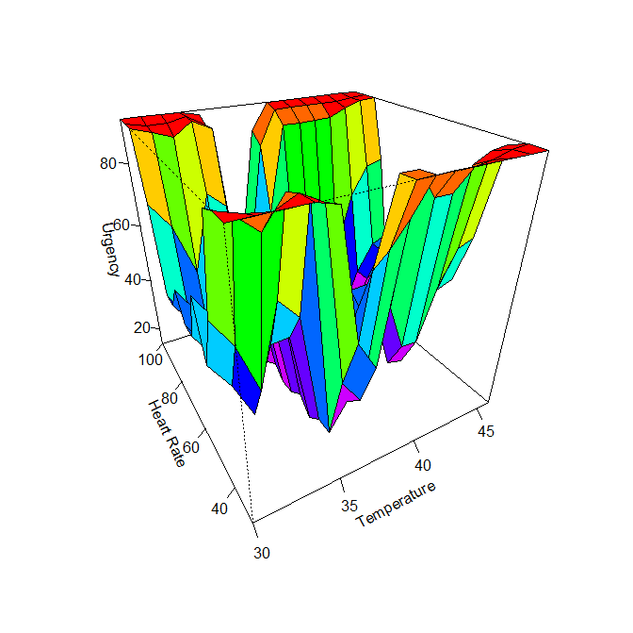

Fig 6 – gensurf graph of model 3

Looking at the results (see appendix apx 3), we can see the RMSE Average is [8.070762] which only roughly a 10X improvement from the results of model 2 (see appendix apx 3). Again this indicates firstly that tuning could greatly improve the results, but also looking at the other model graphs and modifications made from model1 to model3, it can be safely assumed that changing the output variable to accommodate more variance, could potentially produce more accurate reading as mentioned before.

# Section 2

This section will involve showing a detailed overview of the final model, this would include its structure and thus its configuration, potential changes to the set of rules and a brief overview of it results in both graph form and an example case of input/outputs that it takes in and produces.